Assignment 2

Himanshu Goyal (Hgoyal)

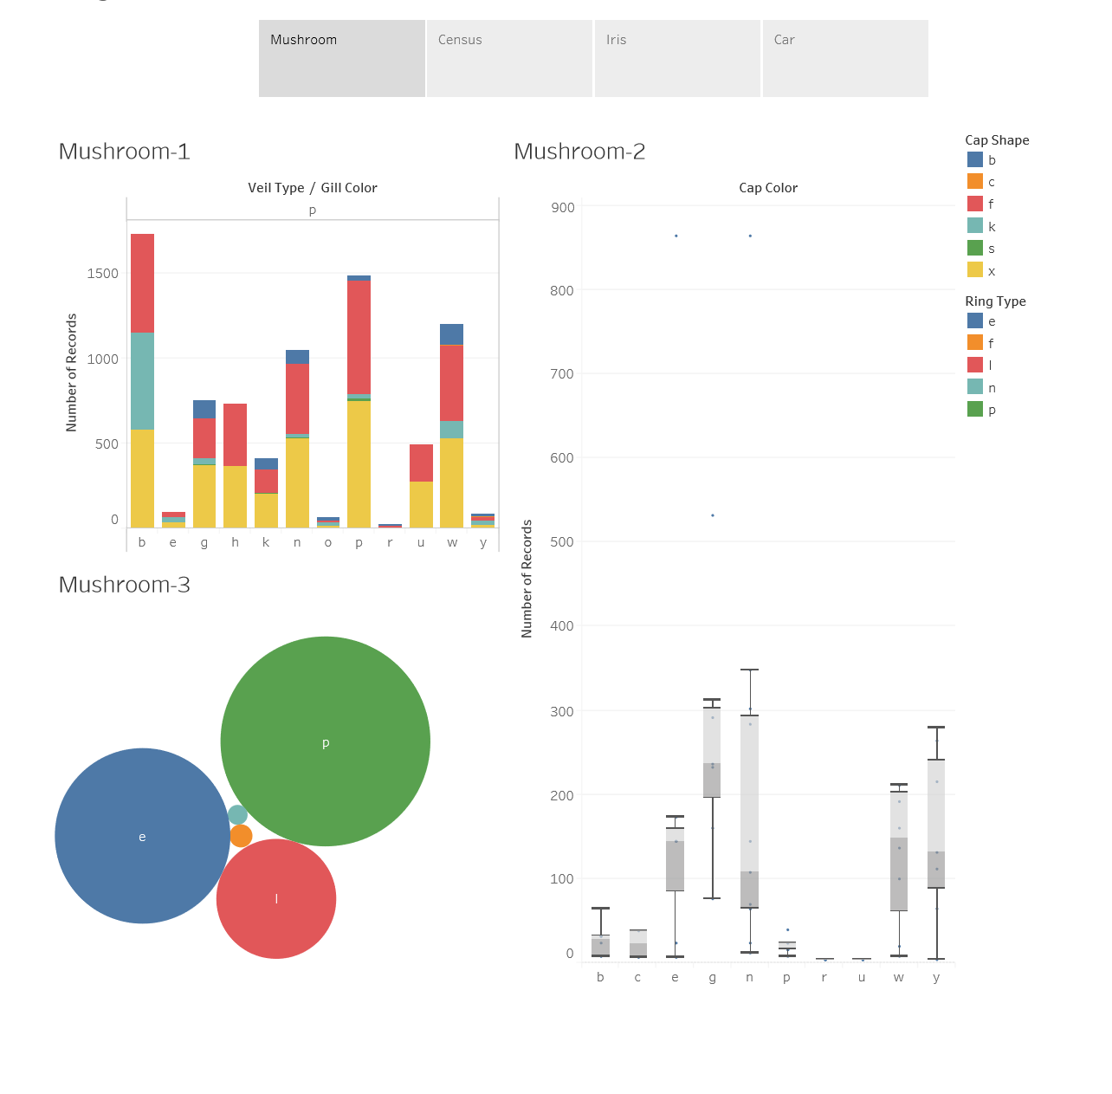

There are two whiskers for cap color type red, The data is not so clustered here.

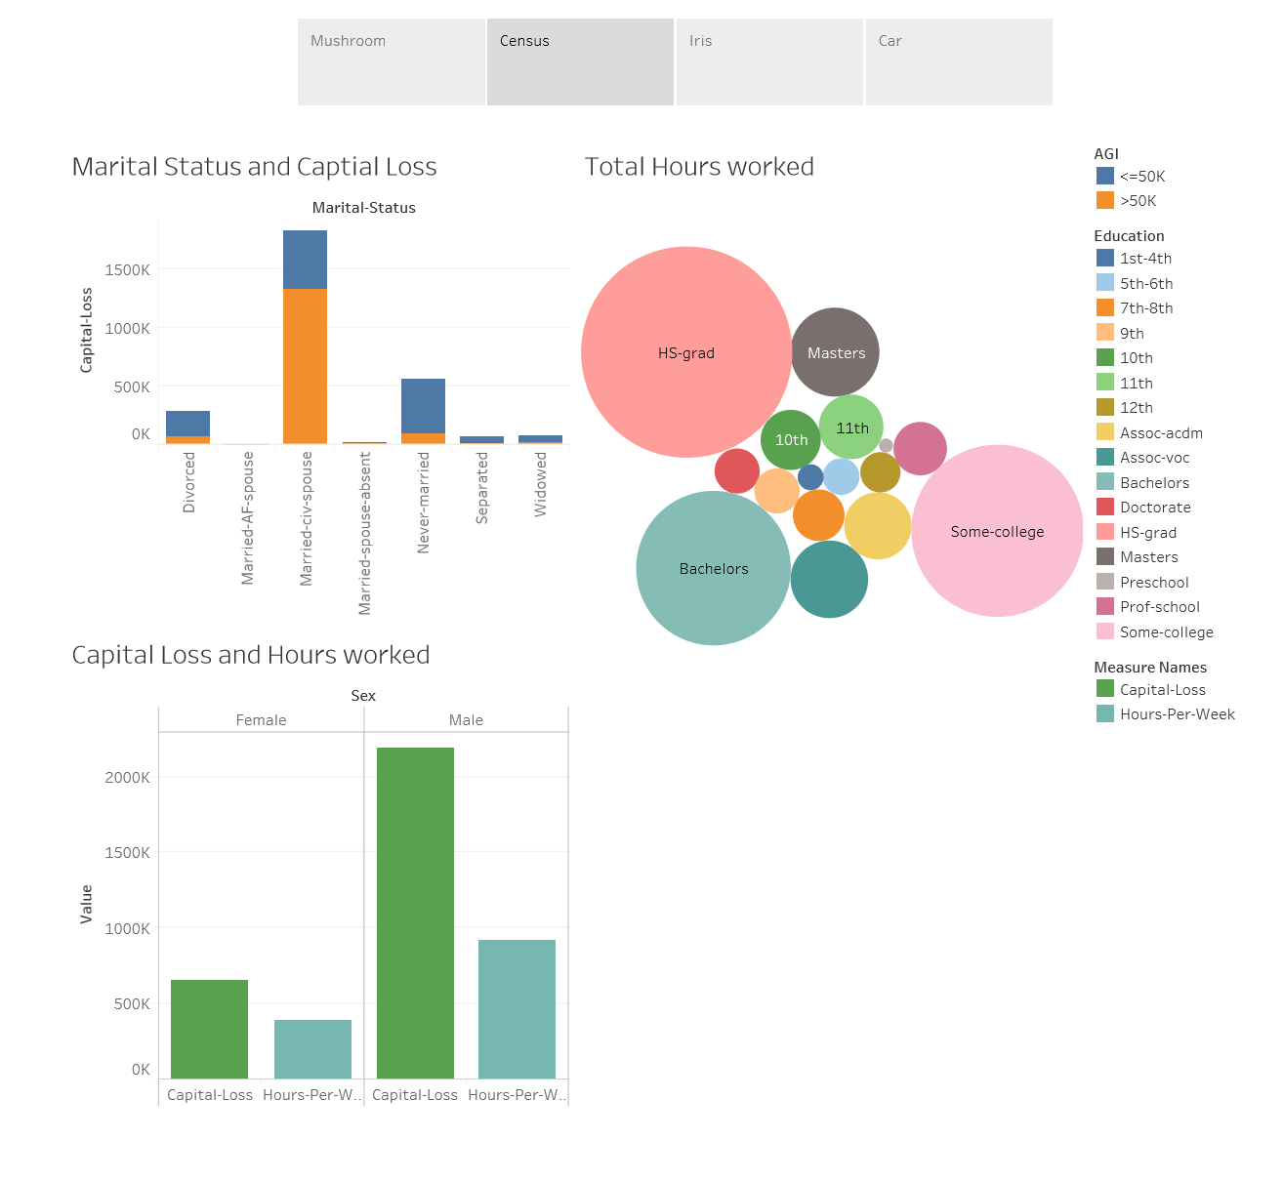

Capital loss for male are more as compared to female given hours per week. We can also say that HS-grad and Bachelors are having more working hours in a given week compared to others.

